VR Environment Support for STEM Students – A Case Study
Mariam Ali Alnuaimi  Department of Computer Science and Software Engineering, UAE University  Al Ain, UAE  Email: 201600912@uaeu.ac.ae  ORCID 0009-0002-3689-6884 | Mamoun Awad  Department of Computer Science and Software Engineering, UAE University  Al Ain, UAE  Email: mamoun.awad@uaeu.ac.ae  ORCID 0000-0001-7424-4129
Mariam Ali Alnuaimi ª and Mamoun A. Awad ª*
ªDepartment of Computer Science and Software Engineering, UAE University, Al Ain, UAE; *Department of Computer Science and Software Engineering, UAE University, Al Ain, UAE, email: mamoun.awad@uaeu.ac.ae
Provide short biographical notes on all contributors here if the journal requires them.
Mariam A. Alnuaimi: Data curation, Formal Analysis, Methodology, Project administration, Supervision, Validation, Visualization, Conceptualization, Funding acquisition, Investigation, Resources, Software, and Writing – original draft.
Mamoun Awad: Data curation, Formal Analysis, Methodology, Project administration, Supervision, Validation, Visualization, and Writing – review and editing.

VR Environment Support for STEM Students – An Educational Case Study

Abstract
Virtual reality (VR) is becoming increasingly popular and essential in education as institutions strive to incorporate technology in education. In Engineering and Computer Science, students face difficulties in comprehending many abstract complex concepts that are typically studied in Labs. This situation worsens with hardware failure and lack of pedagogical tools. The main goal of this paper is to investigate the impact of VR environment on learning advanced and complex STEM concepts. We also explore the impact of gamification on the learning experience of STEM students. To measure such impact, we developed VR application that simulates laboratory course in CS/CE, namely, digital design & computer organization course. We conducted usability study to assure immersive and interactive learning experience. We carried out experiments and surveyed participating university students to measure the learning experience and the impact on learning improvement. Our results show that students who are using VR application perform better than students who use traditional learning. The analysis of the survey indicates that 90% of the participants found that the VR gamification experience was fun and encouraged competitive behavior and contributed to better understanding of the materials. This study reveals the importance of VR environment in engineering education. VR environment makes the learning experience more entertaining and less tedious especially when dealing with complex abstract engineering concepts. The VR environment has additional overhead because it requires development, testing, and more importantly usability studies to incorporate gamification.
Keywords: Virtual Reality (VR), Digital Design & Computer Organization, Education, Gamification, STEM

Introduction
Virtual reality technology (VR) has become interesting technology in advancing various fields, especially engineering and computer science. The use of VR in engineering education has gained momentum because it creates immersive, interactive environments that support learning especially in the STEM (Science, Technology, Engineering, and Mathematics) disciplines. One of the specialized domains is computer architecture which deals with the low-level design and organization of hardware components in a computer system. Although computer architecture course is equipped with traditional laboratory environments, in many cases STEM students face cognitive challenging in grasping abstract and complex concepts using traditional teaching methods (Huang & Roscoe, 2021; Oje, Hunsu, & May, 2023). Research has shown that Virtual Reality (VR) can provide an immersive, competitive, and fun experience during lab sessions which can be considered a solution to general lab limitations (Soliman et al., 2024).
VR technology has been used in various fields, however recent studies identified that VR applications in engineering lack learning theories and objectives integration in the VR design (Soliman et al., 2021). Additionally, there is a research gap in exploring the effects of VR applications as pedagogical tools within the specific domain of engineering education including computer architecture laboratory (di Lanzo, et al., 2020). Moreover, there remain dearth of research examining the effect of VR enriched with gamification techniques and its effect on students.
We believe that by creating an interactive and immersive learning environment, VR applications can revolutionize how students engage in labs advanced topics. To assess this potential, we developed a VR application to educate students on digital design and computer architecture. It is worth to mention that this work is an ongoing research that started with conducting a usability study of our VR application and presented solutions of issues related to VR usability and user experience. In this work, we focus on the educational aspects and cognitive learning aspects. Therefore, we conducted experiments to compare the results of learning and memorization of the class material with and without VR environment. The main contributions of this work are summarized as follows:
- We surveyed research work in VR applications in engineering education and human computer interaction (HCI), including the use of gamification in education.
- We developed VR application to support student experience in Digital Design and Computer Organization course.
- We incorporated gamification aspects to the VR application to test informally the effect of gamification on students’ engagement. We leave the detailed experiments on this topic as future work.
- We conducted educational experiments on a group of undergraduate students to assess the effect of VR environment on their cognitive learning and understanding of advanced CS/CE concepts.
- We analyzed, presented, and discussed the final results.
Our VR application is scalable and it can be extended easily to incorporate other materials in other courses of STEM disciplines to engage students in an immersive competitive environment, involve new interactive technology in teaching methods, and reduce lab costs. The remainder of this paper is organized as follows: Section 2 summarizes related and relevant research work. Section 3 presents the research methodology including the research questions, the VR prototype, and the usability evaluation in this paper. Section 4 elaborates on the educational experiments and results. In section 5, we discuss our findings, draw out conclusions, and discuss future work. Finally, Sections 6 and 7 highlight the limitations for this study and the ethical considerations.

Literature Review
There have been vast research studies on the use of VR environments as pedagogical tools in engineering education. These VR environments are typically supported by Human Computer Interaction (HCI) techniques to allow for interactive, engaging, and immersive cognitive learning experience. In this section, we summarize the current state of the art in two main themes of research that are relevant to our work. First, VR research in engineering education. Second, the use of HCI/gamification technique in those VR educational applications (Román-Ibáñez et al., 2018).

2.1 VR in Engineering Education
The literature has enormous research work on the application of VR in engineering education. Soliman et al. (2021) surveyed different research in engineering education and presented evidences that VR is an excellent tool to improve students’ performance and experience. Similarly, the surveys in (di Lanzo, et al., 2020; Huang & Roscoe, 2021) reaffirmed the increasing popularity and impact of VR in education. However, they found that more extensive exploration in engineering education need to be conducted with clear evaluation metrics in realistic VR scenarios. In a recent review, Oje et al. (2023) found that many VR studies in engineering education lack a clear theoretical or pedagogical framework to guide their design and evaluation. They concluded that engineering VR studies lacked theories of learning, especially cognitive and socio-cognitive aspects of learning. Additionally, they recommended the use of multimedia design and pedagogical principles to make VR applications more effective in education. In the following, we summarize VR research in engineering education per domain.
In chemical engineering, Kumar et al. (2021) surveyed and discussed the social and economic implications, and the identification of the bottlenecks in adopting VR tools. VR technology was used in visualizing chemical processes, chemical plants, process simulation, distillation, and chemical reaction engineering. The authors accentuated that novel educational assessment methodologies are needed to evaluate VR-based learning.
In robotics, Román-Ibáñez et al. (2018) argued that performing experiments in real conditions is expensive in terms of time, money and energy. Thus, they proposed a solution which was developing an immersive VR pedagogical simulator of industrial robotic arms for engineering students. Unlike in real lab environment, the VR simulator allowed all students to design and test virtual robotic arms in 3D environment without any delay due to shortage of robotic arms. Based on their experiments, the authors claimed that real-time and immersion were fulfilled and can be used to enhance the teaching of robotics. The authors in (Hurtado, Valerio, & Sanchez, 2010), introduced a novel VR system to help undergraduate students face real professional situation specially to overcome long/extended hours in laboratories. The system allowed the user to immerse in a robot programming environment. The system was tested within two scenarios. The first scenario was that the user would manipulate the virtual robot with the virtual teach pendant. The objective was to turn on the robot and send it to the home position so it can be programmed. The result was compared with a recurrent failure with the users who only used the robot manually and did the same task. In the second scenario the user was asked to write a program for the robot to perform a task using the virtual environment. The users who received training on the system were able to successfully program the real robot more easily than the users who did not receive the training.
In software engineering, Narasimha et al. (2019) presented a study to understand the feasibility of immersive VR when conducting a collaborative design task-card sorting, with geographically distributed participants. Both usability and qualitative data from the participants indicated significant improvement and engagement. The author of (Akbulut, Catal, & Yıldız, 2018) presented a similar study on the use of sorting algorithms and showed that VR is effective for teaching software engineering courses and it can assist in making traditional teaching approaches more engaging.
In electrical engineering, Ogbuanya et al. (2018) suggested to adopt VR to augment laboratory practices in electrical engineering. In their study, they conducted experiments to measure the effectiveness of Desktop VR on electrical engineering labs. The experiments included the construction of a full wave rectifier circuit and answering questionnaire on the subject. Their analysis concluded that desktop virtual reality had positive impact on students’ academic achievements and engagement.
In civil engineering, the authors of (Shirazi & Behzadan, 2015) implemented an augmented reality (AR)-based information delivery tool, using CAM-ART, in the classroom to enhance traditional lecture-based instruction and information delivery methods. Based on their feedback questionnaire, students found the experience interesting and helpful in gaining knowledge both in short-term and long-term. Sampaio et al. (2010) presented initial VR prototype to manage lighting system management. The VR model allows the identification of the wear and tear aspects of the material in buildings. Although no quantitative analysis was conducted, the study recommended CAD and VR technologies in civil engineering education because such technologies offered visual simulation and prepared students in their professional practice.
Based on our review, we confirm that there is lack of specialized studies in engineering education, and that more extensive exploration of VR in engineering education need to be conducted with clear evaluation metrics and practical scenarios.

2.2 Gamification in VR Engineering Education
The integration of gamification in VR applications in education has become prevalent, very popular, and enormous (Lampropoulos & Kinshuk, 2024; Tayal, Rajagopal, & Mahajan, 2022; Nor, Sunar, & Kapi, 2020; Di Nardo, et al., 2024). Research studies showed that gamification provides positive motivation, and increases the quantity of the learning outcomes of the gamified activities. However, the use of gamification elements in VR environments in engineering education is still moderate and not thoroughly investigated (Lampropoulos & Kinshuk, 2024). In the following, we present relevant research work of integrating gamification as an HCI technique in VR-based engineering education.
In the emerging field of Cognitive InfoCommunications (CogInfoCom), Katona (2021) used Electroencephalography (EEG)-based brain-computer interface (BCI), gesture control, and eye tracking to enable seamless interaction between humans and artificial cognitive agent. They recommended to fuse HCI-based systems and VR environments because that will lead to more creative ways of thinking and knowledge acquisition.
In their review paper on gamification in engineering education, Milosz et al. (2020) found that the use of gamification in engineering education was steadily increasing in all engineering domains. However, there was a dearth of research studies in gamified VR applications especially in computer engineering. In terms of gamification elements, they found that more than 90% of case studies use points. Other elements such as leaderboards, badges/medals and levels/ iterations had a high level of application.
In architecture engineering, gamification was considered in few VR-based studies. These studies used gamification techniques such as game-like features and mechanism, points, virtual rewards, and badges, to incorporate and measure the impact on learning and engagement of students in architecture education. The authors of (Villagrasa, Fonseca, & Durán, 2014) built a VR application to teach 3D art and evaluated students’ motivation, satisfaction, and academic performance using mixed-method (structured test and Bipolar Laddering, BLA). They concluded that VR technology in general can assist the students to engage and improve academically. Fonseca et al. (2020) presented a study to integrate gamification and interactive VR in Project-Based Learning (PBL). The objective is to improve the visualization and understanding of 3D complex models. The data collected via students’ informal feedback and assessments indicated serious issues such as lack of standards, software complexity, long learning times, and teacher’s rejection of using such technology. In their explorative research they found a gender and age gap in accepting VR systems. Other studies in architecture engineering have shown that VR helps increase competences in visualization of complex representation, therefore, students can significantly gain motivation and understanding of architectural and urban space (Fonseca, et al., 2017; Sanchez-Sepulveda, et al., 2019).
In manufacturing, Tan et al. (2022) investigated the use of a virtual reality environment equipped with game-like features and mechanism to enhance students’ knowledge of manufacturing concepts.
In electrical engineering, Nicola et al. (2018) developed VR mobile application with gamification elements to teach electrical students bubble sort algorithm. The objective is to increase students’ learning, experience, interactivity, and engagement with abstract electrical engineering concepts. Their gamification mechanisms included tasks, score/points, timer, and feedback. The authors had only usability testing and recommended not to use the application more than 10 minutes a day to avoid vision problem. The authors in (de Geus, et al., 2020) presented a VR application with gamification to teach electrical engineering students live-line maintenance, in electrical energy substations. Although most users approved the application, the usability test disclosed problems related to “ease of use” especially with participants who had no experience in electrical maintenance.
In computer Science, Oberhauser et al. (2019) showed that gamification techniques, such as task and points, in VR application can be very effective in teaching software structure. Another study by Pineda et al. (2017) proposed a virtual learning environment called TICademia that leveraging gamification and competitive programming. Di Nardo et al. (2024) conducted a review study exploring the advantages and drawbacks of gamification in software engineering education. The study recommended to integrate gamification elements as supplementary tool rather than a replacement of traditional teaching methods.
In nuclear engineering, Smith et al. (2021) presented a study to help the visualization of attenuating radiation using VR model that uses gamification mechanism.
In computer engineering, the authors of (Burgos, Guevara, & Espinosa, 2021) designed and experimented an augmented reality educational application to teach students various associations of electrical resistances schemes, simple circuits and the use of other electronic components. Based on their quantitative analysis, questionnaire and test, they found that the application had great impact in collaborative work and encouraged students to achieve 20% higher in the academic performance test. Similar findings were drawn in the study (Weng, Tran, Yang, Huang, & Chen, 2024) in which 29 high school students participated in piloting an AR-integrated gamification learning application to learn electronics course. Eniola et al. (2023) studied the integration of the extended Unified Theory of Acceptance and Use of Technology (UTAUT2) in the gamification of basic electronics. They used CRUMB Circuit Simulator to measure the students’ behavioral intention. They concluded that CRUMB simulator enhanced learners’ likelihood to complete tasks and improved their productivity.
In this paper, we present a VR application to educate computer engineering students on digital design and computer architecture concepts. Our VR application is equipped with different gamification elements such as levels, hints, score, and leaderboard. This work is a continuation of the previous work (authors 2025, in press), in which we presented a usability study of our VR application and presented solutions of issues related to enhance VR usability and user experience. In this work, we focus on the educational aspects and the learning experience results. We conducted quantitative experiments of the VR application in education to compare the results of learning and memorization of the class material with and without VR environment.

Research Methodology
The research methodology in this study employs combining quantitative and qualitative data collection techniques to gain a comprehensive understanding of educational attributes and user experience within the Digital Design & Computer Organization lab VR application. Additionally, we use surveys to gather user feedback, comments, preferences, and experiences.
Figure 1 presents our research methodology which includes defining research questions and goals, developing and implementing VR prototype, designing usability quantitative metrics, developing surveys, and finally collecting data and analyzing the usability of the VR system. The following sections present each step and provide elaborate explanations.

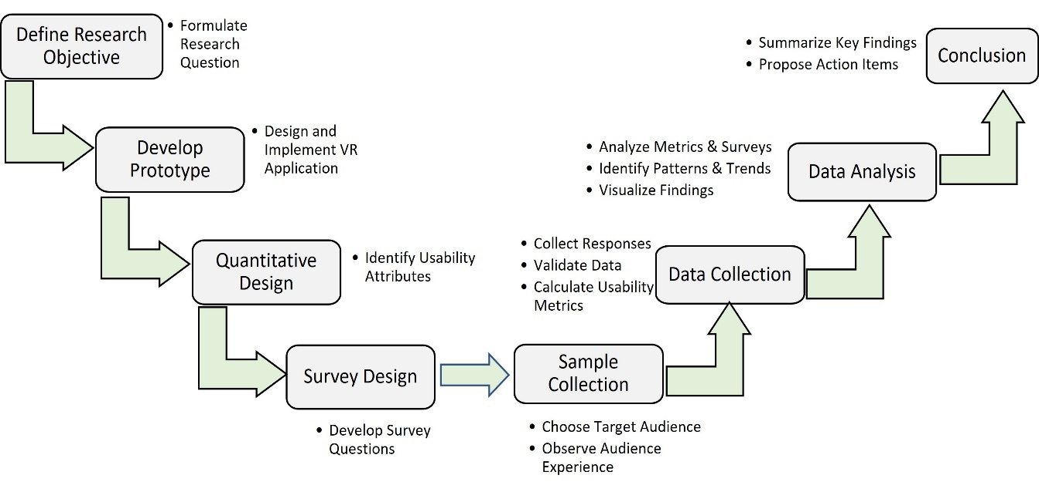
Figure 1 Research Methodology Steps

3.1 Research Questions
This study aims to identify the extent to which our VR application can be used by a specified audience, namely undergraduate computer science and engineering students, and achieve the goal of replacing the physical environment, composed of breadboard, when needed with effective, efficient, and easy-of-use VR application. We define our research questions as follows.
- RQ1: Does the use of a VR environment, compared to traditional materials-based learning, influence learners' task performance, perception, and understanding of complex engineering concepts?
- RQ2: How does VR environment learning correlate with task performance?
- RQ3: Will the VR gamified environment stimulate students’ engagement to learn complex engineering concepts?
- RQ4: What are the advantages and disadvantages of a VR system in student engineering education?

3.2 Methods
To answer the proposed research questions (RQs), we use quantitative and qualitative methods for data collection. We designed and conducted a within-subject experiment with university students to compare the effect of VR based learning with traditional learning. We prepared and conducted cognitive test to measure cognitive improvement. Additionally, we surveyed the students and solicit their feedback on the VR environment and the embedded gamification elements, see Table 1.
Table 1 Measurement of Research Questions
Research Question | Measurement Method
RQ1 | Quantitative method – Cognitive test
RQ2 | Quantitative method – Cognitive test
RQ3 | Surveys and students’ feedback – one sample t-test
RQ4 | Analysis of the survey, feedback, and observation

3.3 Prototype Development
Digital Design and Computer Organization (CENG205) is a core undergraduate course in the College of IT at UAE (United Arab Emirates) University. The course introduces students to the basic concepts of digital systems, digital logic gates, truth tables, and combinational and sequential logic circuits. The course is equipped with hands-on labs that bridge the gap between theory and practice. In this section, we briefly present the specifications of the VR application of digital design & computer organization lab. The VR application simulates the physical Lab of Digital Design and computer Organization and includes hands-on the five essential logic gates, namely, AND, OR, NOT, NAND, and XOR. Additionally, it includes two complicated level gates: 1bit comparator and half adder. This VR environment will enable us to observe students’ progress in learning logic gates. Moreover, the VR application supports gamification techniques to enhance students’ engagement. The main purpose of the prototype is to allow students to learn and conduct the experiments independently.
With regards to hardware requirements, we observe that researchers used different VR tools (such as interactive websites, 3D desktop models, and VR gaming with headset and controller) to enhance students’ engagement. In this research, we choose to implement the VR application using Unity/Oculus headset and controller. As we will discuss in the results section, we found that students get better motivation and engagement when using new technology rather than using traditional websites or desktop application.
The VR application is designed to help student easily navigate and conduct labs to gain knowledge. It is equipped with ROBO gadget that provides written and audio assistant to students to guarantee full scale benefits. The VR prototype provides different functions to the actors/users such as login/register, viewing lab materials, conducting lab experiments in different levels, showing scores, redoing lab experiments, and others.

The VR application includes the following components:
- Main menu to allow students to login/logout and register. This allows the application to keep track of their scores and progress individually.
- Lab list: a list of all available labs. Each lab displays options for the student. The options include start lab and leader board.
- Virtual Companion Robot (ROBO): is a gadget that provides written and audio assistant to students to guarantee full scale benefits. ROBO would explain each tool when clicked on. The learner has the option to switch between written and voiced instructions. Additionally, while conducting the labs, the student can follow ROBO instructions, receive hints, and request to repeat steps until completing all the steps in that lab. With the help of ROBO, students stay focused without getting distracted of switching between different lab materials/resources.
- The lab level: this part allows students to use the controllers as hands to carry objects and place them in highlighted areas as guided by ROBO (virtual companion robot). They will be able to see hearts on the left side. The hearts represent the attempts to submit the steps. Each lab will provide 3 hearts in which the student is redirected to the game over page if they skipped a step or didn’t follow the instructions correctly three times. On the right corner of their vision, they will see a timer that starts as soon as the lab starts. The timer will record each student's time score and save them on a leaderboard. The student will have the option to leave the lab.
- Game over page: this page will be displayed to the student when submitting a failing attempt three times. The page will display an encouraging line for the student and provide an option to leave or retry the lab.
- Done page: when a student successfully submits a lab a victory page is displayed and the student's time score is shown to the student. Students will have the option to try the lab again or leave the lab.
- Leaderboard page: each lab will have a leaderboard page. this page will display the student's scores. The less time the students spend on the labs, the higher their placement is.
- Help page: the help page includes general information about how to use the application and the headset controllers.
- About circuit components page: this page includes a list of components used in the labs. ROBO would explain each tool when clicked on. Each tool has highlighted areas for the user to click on to get more specific information.
The VR application has the following additional HCI aspects:
- Constant color theme: light blue for backgrounds, blue for clickable buttons, white for text, and Liberation Sans SDF Material for font.
- Constant icon colors.
- Clear ROBO audio for the students to understand the labs.
- Circuit diagrams, K-maps, and logical gates graphs to assist the students.
- Ability to leave anytime.
Figure 2 shows the hierarchical task analysis of the environment. Table 2 summarizes the gamification elements used in our VR environment application.
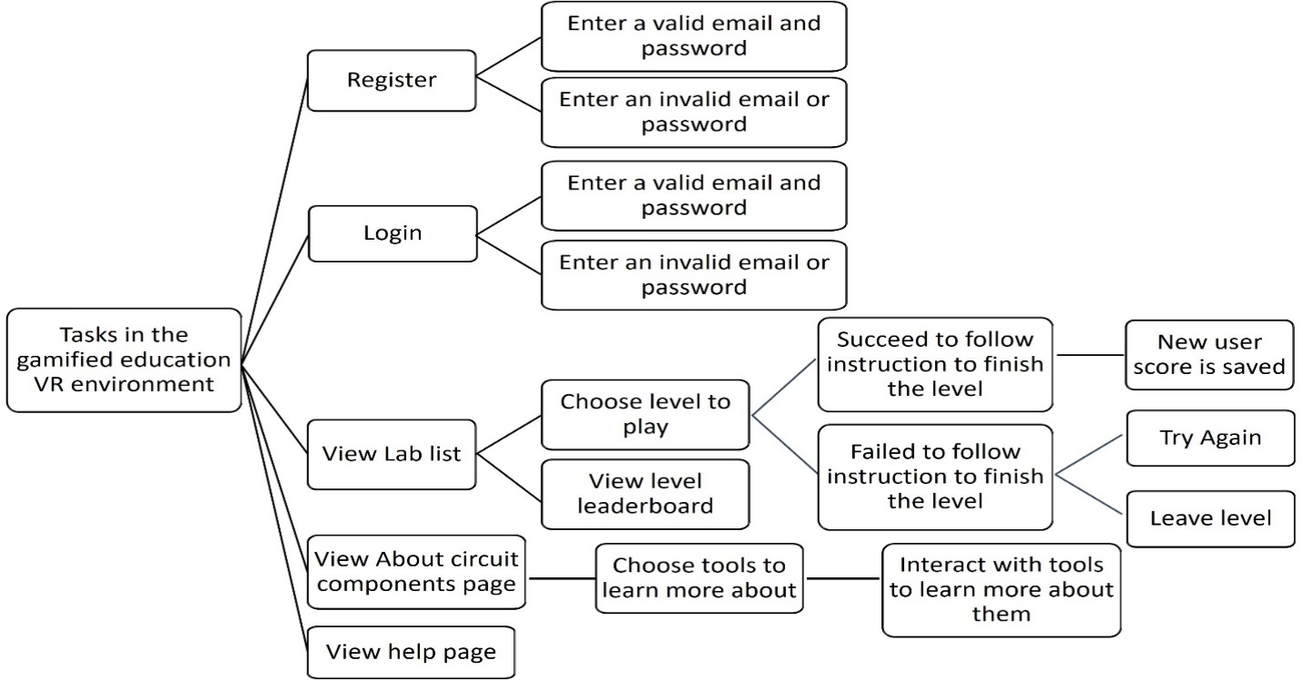
Figure 2 Environment task analysis

Table 2 Gamification elements used in the VR application.
Gamification elements | Description | Aim
Levels | Different lab levels with different difficulties. | Encourage students to climb up levels and improve their skills.
Score | The Time in seconds spent in every lab. | Increase students’ awareness of their performance in levels
Lives (Hearts) | Indicates how many more attempts the student has. The student will have 3 lives each level. | Remind the students to see practicing and repeated attempts as a chance to master the concepts and techniques involved in the lab.
Game Over condition | When the student reach 0 lives they face the game over page. | Challenge them to reattempt the lab and practice.
Hints | Highlighted areas of the same shape of object to help students place objects. | Hints unlock understanding, one clue at a time.
Helper NPC | ROBO is an NPC that provide instructions to students. | Guide the students in a fun inspiring way
Leaderboard | Display students’ scores (time) from less time to longer times. | Encourage competitiveness to push boundaries, refine skills

In the following, we present briefly the main functions and screens of our gamified VR educational application. More details on software requirements specifications (SRS), use case specifications, and UI can be found on GitHub (Alnuaimi & Awad, GitHub Link to Supportive Documents and Article Resources, 2024). Figure 3 shows the main landing page which includes application title, login, and register options. Figure 4 presents the available educational labs that the student can view and provides options to start/stop the Lab.
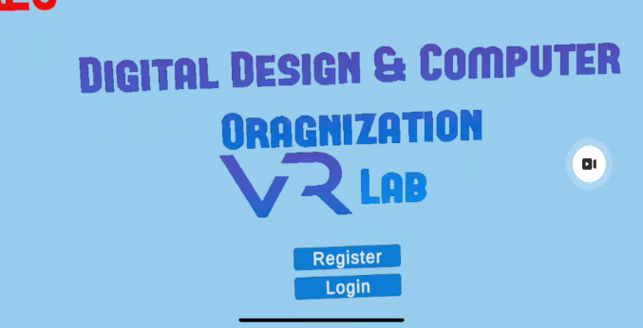  Figure 3 Landing Page - main menu | 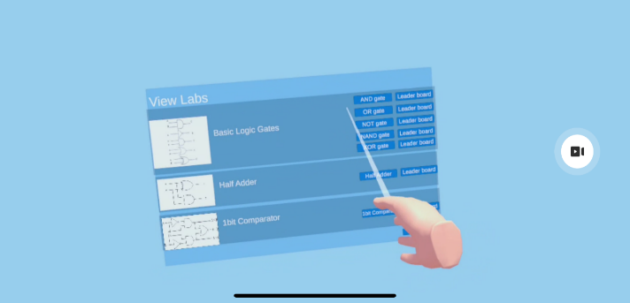  Figure 4 Lab list page, where student can choose lab to learn
The student can conduct the lab by following steps recited by a virtual robot. The Lab page includes a virtual robot (ROBO) companion that guides the student through the lab with voiced instructions. While conducting the lab, students will be able to use the controllers as hands to carry objects and place them in highlighted areas as guided by the ROBO Figure 5. In addition, students can gain hearts after successful completion of the lab steps. In case the student did not follow the steps correctly, she is redirected to the “game over” page. Furthermore, the student can see a timer that starts as soon as the lab starts. The VR application will record lab completion time and view it on the leaderboard.
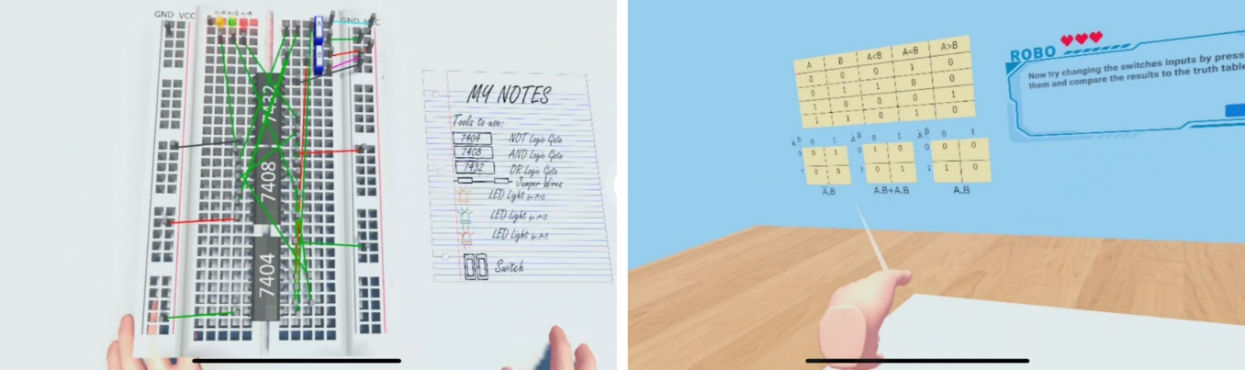
Figure 5: Conducting Lab level, 1-bit comparator with truth table and K-maps hints
The student can check her score and progress through the leaderboard page, Figure 6. Each student is displayed on the leaderboard showing her score and lab completion time. Moreover, the student can use the Help page to learn more by viewing documentation and manual pages, see Figure 7.
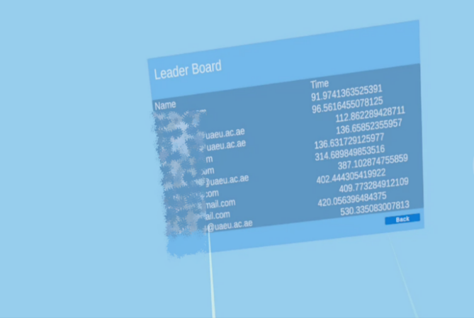  Figure 6 Leaderboard page, note: students emails and names were disguised. | 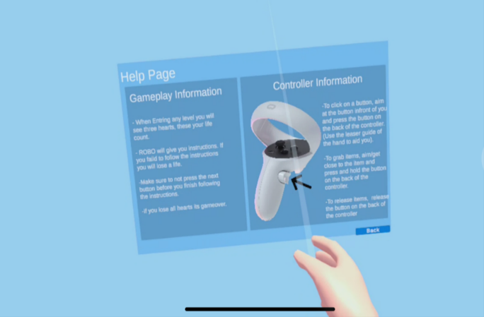  Figure 7 Help page on the controller

The reader can observe that in Figures 4-8 the interaction of the user with the VR application seems somehow similar to the traditional desktop or 3D interactive website applications, where clicking, dragging, and dropping are the dominant actions. However, the VR headset and controller offer more impactful and engaging interaction compared to 3D websites or desktop allowing for a more realistic sense of presence and a higher degree of physical interaction (Kumar, et al., 2021; Shirazi & Behzadan, 2015; Sampaio, Ferreira, Rosário, & Martins, 2010). With regard of costs, both 3D interactive websites and VR applications can reduce the cost of the physical Lab. Although 3D interactive websites are less costly the VR environment provides better immersive and engaging experience. In addition, the cost of VR headset is witnessing dramatic decrease, for example the VR headset can range from $100-$600. In our VR application and based on Unity documentation, we still can reduce cost by deploying the VR application on a website or a desktop and let students use traditional input means to interact with it.

3.4 Usability Evaluation
In previous work (authors, 2025, in press), we conducted usability study of the VR application. The usability evaluation was based on sample of 22 undergraduate IT students. We accumulated data and analyzed different metrics such as completion rate, error rate, task time, etc. We also conducted observation testing, and conducted one-one interview with the audience. In this section we briefly highlight the main issues and remarks from the students: 90% of the students thought that the VR application was not crowded, easy to use, close to the real lab, simple, clear, and well organized. In terms of appearance and consistency, 95% of the students thought the application is consistent and not confusing. However, the study reported issues with the keyboard location, wires coloring, picture clarity, and unawareness of hearts being lost. The authors fixed these issues and redesigned the application accordingly. In conclusion, the usability study showed that the majority of students found that the VR application immersive, engaging, and viewed their experience as helpful to better understand complex concepts.

Educational Experiments
In this section, we will present and analyze the results of the educational experiments and the survey that we conducted to answer the research questions. We followed the approach in (Lucas, 2018), however, we focus more on the learning curve and how gamification and VR affect learning. Therefore, we have two samples/groups: experimental group that uses the VR application, and control group that uses traditional reading of documents to learn the material presented. The goal is to know which test sample will perform better. In both groups, we identified the following learning objects for the participants to learn:
- Basic logic gates, e.g., AND, OR, NAND, etc.
- Basics of Electric board using the physical lab
- Advanced circuits that include half-adder and 1-bit comparator

4.1 Sample and Experiment setup
Our educational experiments were conducted on 24 undergraduate students from the UAE University, the largest federal university in the UAE which admits mostly UAE nationals. Eighty three percent of the participants were UAE national and 17% were expatriates. All subjects registered voluntarily in the learning activity and were randomly assigned into the two groups. Among all volunteers only 3 students had VR experience. The technical background of the students included engineering (9), information technology (8), science (3), and other colleges (4). All subjects were older than 18-year-old (mean age 20 ± 1.5 years) and signed an informed consent. The experiment was done based on booking a day and time stamp for each participant. We divided the students randomly into two 12-student groups. The experimental group (Group-A) includes the use of VR application to learn as much of the Digital Design & Computer Organization lab materials that are provided in the application. The control group (Group-B) uses traditional paper documents that provide the same learning materials as the application does and learn as much as they can from it. Both groups were given a 5-minute pre-quiz of the Design & Computer Organization lab materials to measure their base knowledge on the subject.
The experiment flow of Group-A after taking the pre-quiz is as follows. First, a summary of the application idea and functionality was presented to the students for 3 minutes. Second, if the student was not part of the first usability test (authors, 2025, in press), she was given a demo of how the application works as well as 5-minute training on the VR headset. Third, the participants were warned about the motion sickness that the VR headset might cause, and they were instructed to request from the experiment conductor to stop the experiment in case they feel motion sickness. Fourth, the students were given one hour to navigate through the application freely and use it to learn as much as they can from the materials presented. Last, participants were given a 7-minute post-quiz to measure their improvement on the subject. The post-quiz includes questions from the pre-quiz and extra questions that were not seen before, see Table 4.
The experiment flow of Group-B after taking the pre-quiz is as follows. First, a document with the exact same materials as the application was given to the participants. Second, one hour period was given to read and study the materials. Last, participants were given a 7-minute post-quiz to measure their improvement on the subject. After collecting the data, the results of the Pre-Quiz and Post-Quiz are compared to calculate the improvement of the participants.
Table 4 presents sample questions of the pre/post quiz questions that we designed to assess the education improvement of the students in both groups. The quiz has 2 main sections: definition section to test concept definition understanding, and image section to recognize different circuit components. Additionally, extra questions section was introduced.
In terms of gamification and enthusiasm of the VR learning, we surveyed the students in Group-A by asking the following questions in Table 3.
Table 3 Gamification and Enthusiasm Survey Questions
Number | Question | Question Type
Q1. | Was everything clear and easy to preform without frustration? | Likert scale 1-10, 1=low
Q2. | Did you managed to perform well in labs without difficulties in using the VR equipment? | Likert scale 1-10, 1=low
Q3. | Did you find the application interesting? | Likert scale 1-10, 1=low
Q4. | Did you find the gamification elements fun and encouraged competitive behaviour? | Likert scale 1-10, 1=low
Q5. | What parts of the application did you think represented game aspects and were fun to experience? | Open-ended
Q6. | Would you recommend the application to other students? | Open-ended

The education experiment data including Pre-Quiz questions, Post-Quiz questions, and responses are public and can be accessed on GitHub (Alnuaimi & Awad, GitHub Link to Supportive Documents and Article Resources, 2024).
Table 4 Sample of quiz questions used in the study to assess students’ knowledge and improvement.
Definition Section |  |  |  | Choices/Answer
Q1 | AND logic gate |  |  | - It generates a high or logic 1 output, only when all the inputs applied to it are high or logic 1. (correct)  - Produces a low or logic 0 output only when all its inputs are low or logic 0  - It takes only one input and one output.
Q2 | NOT logic gate |  |  | - Produces a low or logic 0 output only when all its inputs are low or logic 0  - The output is true if either, but not both, of the inputs are true.  - It gives 0 when input is 1 and 1 when the input is 0. (correct)
Image Section |  |  |  |  | Question Text | Choices/Answer
Q1 |  | 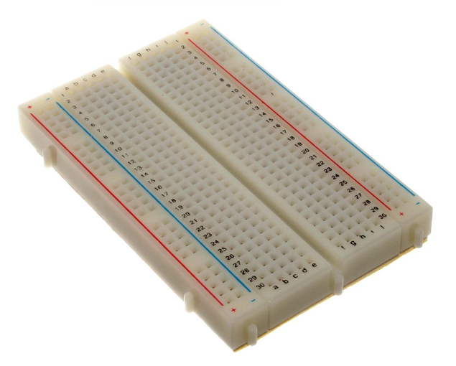 |  |  | What is the item in the above picture called? | - Electric Board  - Bread Board (correct)  - Circuit Board  - Strip Board
Q2 |  | 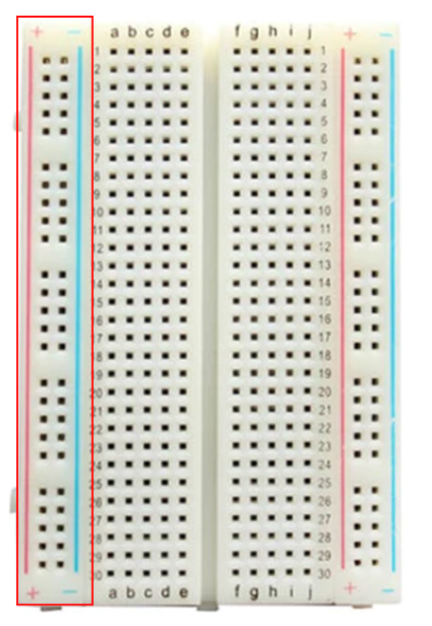 |  |  | What is this part of the board called? | - Terminals  - Power Rails (correct)  - Center Divider
Extra Question Section |  |  |  |  | Choices/Answer
Q1 |  |  | What does the Half-adder circuit do? |  | - Performs binary addition of two single-bit binary numbers (correct)  - Performs binary addition of three single-bit binary numbers  - Compare two bits  - Compare two binary numbers each of four bits
Q2 |  |  | What does the 1-bit comparator circuit do? |  | - Performs binary addition of two single-bit binary numbers  - Performs binary addition of three single-bit binary numbers  - Compare two bits (correct)  - Compare two binary numbers each of four bits

4.2 Educational Experiment: Pre-Quiz
The objective of the pre-quiz is to measure students’ base knowledge to make sure that students in both groups have similar academic/mental capability. The pre-quiz normalized scores of students in Group-A vs. students in Group-B are presented in Figure 8. The figure shows the scores in the definition section, image section, and the total score for each student, as well as the average scores of the whole group. We can observe that the average score in all sections of Group-A is 47% while the average score of Group-B is 43%, see Table 5. The p-value of each section (>0.05) of the pre-quiz test indicates strong evidence that both groups have similar base knowledge on the topic.
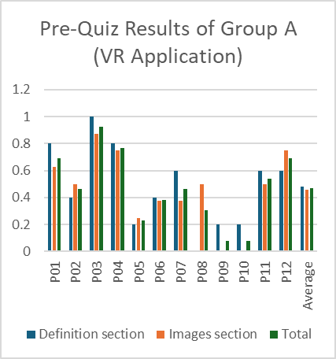 | 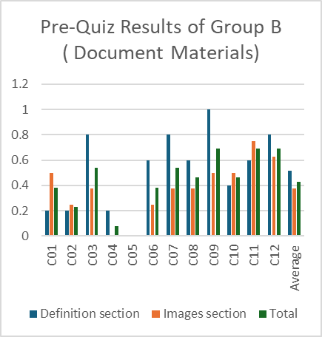
Figure 8 pre-quiz results of students in Group-A vs. in Group-B
Table 5 Average scores of both groups in each section
Group | Definition Section |  | Image Section |  | Total
 | AVG | STD | AVG | STD | AVG | STD
Group-A | 0.48 | 0.30 | 0.46 | 0.27 | 0.47 | 0.26
Group-B | 0.52 | 0.31 | 0.38 | 0.22 | 0.43 | 0.23
P-Value | 0.74 |  | 0.32 |  | 0.60

4.3 Educational Experiment: Post-Quiz
The objective of the post-quiz is to measure students’ improvement in understanding CS concepts using VR application vs. the use of traditional documentation. Recall that the post-quiz includes repeated questions from the pre-quiz and new questions from the Extra Question section, see Table 4. The post-quiz normalized scores of students in Group-A and Group-B are presented in Figure 9 and Figure 10, respectively. The figures indicate that the scores are higher for students in Group-A in all sections. Table 6 presents the average, standard deviation, and the p-value of the scores in each section. We can observe the following.
- The average score in all post-quiz sections of Group-A (83%) is higher than scores of Group-B (58%). This answers RQ1 because it shows that there is a difference between VR environment learning and traditional document-based learning.
- Group A's higher post-quiz scores are statistically significant in two areas—the image section and the extra questions—as well as in the overall score (p-value < 0.05). This finding offers insight into RQ2, suggesting a positive correlation between VR-based learning and improved learning outcomes.
- Group A’s higher scores in the definition section are not statistically significant. This may suggest a potential limitation of VR-based learning when it comes to memorizing conceptual information rather than engaging in hands-on activities, as related to RQ4.
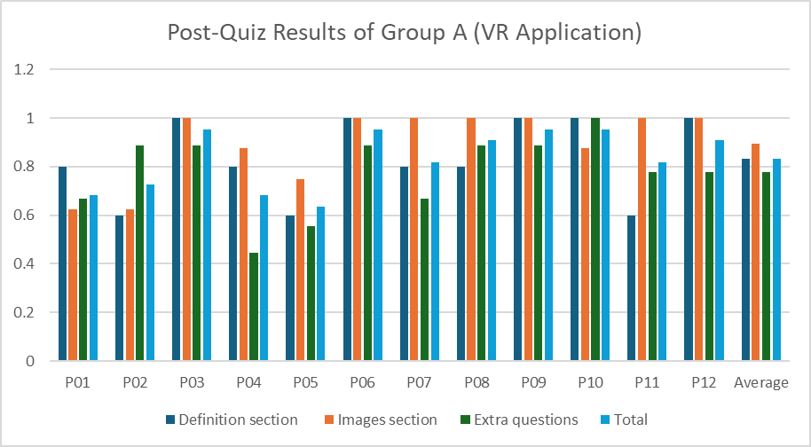
Figure 9 post-Quiz scores of students in Group-A that has 12 students P01-P12.
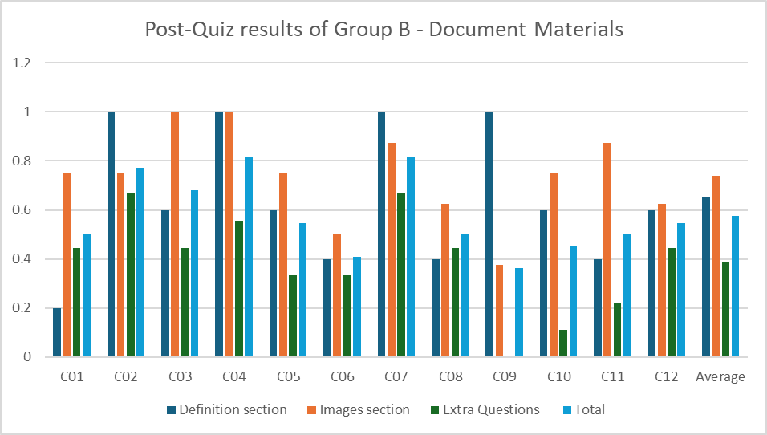
Figure 10 post-Quiz scores of students in Group B that has 12 students C01-C12.
Table 6 Averages of Group-A and Group-B in the post-quiz.
Group | Definition Section |  | Image Section |  | Extra Questions |  | Post Quiz Total
 | AVG | STD | AVG | STD | AVG | STD | AVG | STD
Group-A | 0.83 | 0.16 | 0.90 | 0.14 | 0.78 | 0.16 | 0.83 | 0.12
Group-B | 0.65 | 0.28 | 0.74 | 0.18 | 0.39 | 0.20 | 0.58 | 0.15
P-Value | 0.0621 |  | 0.0237 |  | 0.0001 |  | 0.0001

In terms of improvement, we calculated the average number of questions that was answered incorrectly by each group in the pre-quiz and that was answered correctly in the post-quiz, or vice versa. Table 7 presents the improvement results in both groups. We can observe the following.
- In Group-A (VR group), students have an average of 5.25 (1.75 + 3.5) points improvement which compiles to 40% average improvement. On the hand, students of Group-B achieved 3.57 points improvement which compiles to 27% overall.
- Although, the average of improvement (test recall) in Group-A is clearly higher than in Group-B, it is not statistically significant as p-value > 0.05.
Table 7 Improvement in Post-Quiz (Test Recall).
Group | Definition section  Point Improvement |  | Image Section Point Improvement.
 | AVG | STD | AVG | STD
Group-A | 1.75 | 1.66 | 3.50 | 2.54
Group-B | 0.66 | 1.19 | 2.91 | 2.57
P-Value | 0.15 |  | 0.57

In terms of gamification and enthusiasm of the VR learning (RQ3), we collected the responses of the 22 students who answered the questions shown in Table 3. The results of questions Q1-Q4 are summarized in Table 8. Recall that the questions are rated on a Likert scale from 1 to 10, where 1 indicates low rating and 10 a hight rating. A one-sample t-test was conducted using a hypothetical mean of 7.0, revealing that the observed differences in responses are statistically significant. Therefore, we can conclude that the students were enjoying the learning experience (Q1-Q3) and that the gamification elements did encourage and improve their engagement and enthusiasm (RQ3).
Table 8 VR application Survey on engagement and gamification (one sample t-test results: hypothetical mean: 7/10)
Question | AVG | STD | SEM | p-value
Q1 | 8.5 | 2.57 | 0.535 | 0.0105
Q2 | 8.72 | 2.33 | 0.486 | 0.0018
Q3 | 9.86 | 0.63 | 0.13 | 0.0001
Q4 | 9.63 | 1.32 | 0.275 | 0.0001

Additionally, in the open-ended questions Q5-Q6, we received the following feedback regarding gamification and recommendation the VR application to other students. Table 9 lists the responses which clearly show that gamification encouraged students to learn and to share the benefits with other students.
Table 9 The open-ended question on VR application - gamification aspect
Q5. What parts of the application did you think represented game aspects and were fun to experience? | Q6. Would you recommend the application to other students?
Everything was interesting and fun since I don't have any experience in labs. | Definitely yes!
Putting all the chips and wires together | Yes
Starting the circuit | Yes
To get the result that I was excepting from the lab | Yes definitely
I liked experimenting with the wires and doing the labs and I loved the leader board | Yes
Build | لاشي (Nothing)
The limited hearts made me think twice about the placement so I don’t lose, and it’s fun to compete with your colleagues in the leader board | definitely
The physical board with wires and other components. | Yes, for sure
Switching the LED ON AND OFF | yes
The part where it showed me that I was wrong in some of the applications and I was very satisfied when it worked | Yes, it helps a lot and shows how it can help knowing how a real bread board works
Leader board time and hearts | Yes
Performing the task was easy and well guided for someone who is playing for the first time | Yes
The way we can interact to build the circuit with instructions | Yes, to kids
Part of experiment when putting the wires and gets into the breadboard | Yes, they will get interested in VR &IT
Placing wires | Yes
Everything was enjoyable and fun | I have already told my family also my friends about it 💗💗

Discussions and Conclusion
This paper presents a VR application in education to help STEM students enjoy learning. We built the VR environment simulating a standard lab course in computer engineering curriculum. We strived to bring forth innovation in its disciplinary perspective by incorporating HCI concepts, introducing gamification, and additional game concepts while learning. In order to measure the impact of VR technology in this subject, we conducted educational experiments to measure the cognitive learning of 24 undergraduate students from the UAE University.
Our findings in cognitive learning are based on quantitative experiments on two groups, namely, Group-A that uses VR environment in learning, and Group-B that uses traditional learning. Based on the pre-quiz, the two groups had comparable and similar background knowledge on the topic, Table 5. This led us to believe that the two groups started on similar grounds, and it was fair to compare their results after starting the Experiment. During the experiment, we found that Group-A showed more enthusiasm and excitement to start the experiment than Group-B. This finding is drawn from the results of the Post-Quiz results. The average score in all post-quiz sections of Group-A was 83% versus 58% in Group-B. The difference in scores is statistically significant; hence, we addressed our research questions RQ1 and RQ2, see Table 6. On the other hand, there was a good amount of improvement in learning (40% for Group-B versus 27% for Group-B), though it was not statistically significant. Additionally, Group-A outperformed Group-B in the Extra questions section. Recall that the Extra Question Section has unseen questions while image and definition sections had repeated questions from the Pre-Quiz test. In all cases, students were not told of this fact. Generally, the results are consistent with the findings in (Shirazi & Behzadan, 2015; Sampaio, Ferreira, Rosário, & Martins, 2010; Ogbuanya & Onele, 2018).
With regard to gamification, our usability study (Q1 and Q4 in Table 8) indicated that 96% of students enjoyed the VR application with gamification elements, and 85% of the students used the application smoothly without frustration, see Table 8 and Table 9. These results answer the impact of gamification on learning as stated in RQ3. Learning using the VR application was more successful in engaging students and allowed them to complete labs, learn with joy, and perform better in the cognitive experiments. The results support other VR engineering studies in education (Narasimha, Dixon, Bertrand, & Madathil, 2019; Akbulut, Catal, & Yıldız, 2018), and indicate that VR environment should be used as a supportive means and on a larger scale in physical labs. Though careful integration of VR must be considered because it might cause cybersickness.
On the advantages and disadvantages of VR application (RQ4), and based on our observations, survey, and student feedback, the VR application seemed very appealing for the students, positively encouraged them to perform better, and satisfied their curiosity in new technology. The feedback from students indicated that students would learn better due the capability of repeating the labs, availability of the VR application locally, and less susceptibility of hardware failure. On the other hand, some students suffered from sickness, drowsiness, and discomfort while using the application. Additionally, some students found difficulty to see icons and letters on the keyboard. These issues were resolved by adjusting colors, keyboard location, and introducing such effect to students in advance before attempting the VR application. Overall, we believe that this VR-lab can be extended to incorporate other STEM courses and help engage students in an immersive and competitive environment, involve new interactive technology in teaching methods, and reduce lab costs.
For future research, we plan to improve the VR application by creating multiple leaderboards based on various performance metrics, such as speed and accuracy. Additionally, we plan to conduct larger scale quantitative experiments to evaluate the effect of gamification elements on learning advanced concepts in computer architecture. Moreover, due to the availability of other interactive learning techniques such as web-based, enhance lectures, flipped classes, video enhanced instruction, etc., we will explore a research venue of conducting comparison between VR and other interactive techniques. Finally, we plan to deploy the VR application in a live course and investigate the impact of gamification and VR on the academic level of students and the learning outcomes achievement of the course.

Limitations of the study
In this paper, we investigated the students' preferences in the VR application to learn digital design course labs. We analyzed the survey results on the student's experience with the VR environment and their acceptance of the technology. Students from different colleges applied for the experiment, however, the sample size of 24 students may not be generalizable to the entire population of the Digital Design & Computer Organization lab course. Also, the study focused on the Digital Design & Computer Organization lab VR environment limiting the findings to only this educational course rather than other courses that can be implemented in VR. Additionally, there was a shortage of resources, we had only one VR headset to test with thus the experiment was time-consuming. Future research with larger and more diverse participant groups, as well as studies conducted in actual classrooms, could provide more comprehensive insights.

Ethical Considerations
The surveys in this work were conducted according to the guidelines Institutional Review Board (or Ethics Committee) of the United Arab Emirates University (protocol code ERSC_2022_2029 and date of approval 23/02/2023), copy of the ethical form can be found at (Alnuaimi & Awad, GitHub Link to Supportive Documents and Article Resources, 2024). Informed consent was obtained from all subjects involved in the study. Prior to starting of the survey and the experiment, the authors explained to the students the procedure and the usage of the application. The purpose of the study was not explained in advance so as not to influence students’ responses. Students were instructed that they can discontinue participation or decline to respond to any of the questions in the survey. All students provided spoken informed consent

References
Akbulut, A., Catal, C., & Yıldız, B. (2018). On the effectiveness of virtual reality in the education of software engineering. Computer Applications in Engineering Education, 26, 918–927.
Akçayır, M., & Akçayır, G. (2017). Advantages and challenges associated with augmented reality for education: A systematic review of the literature. Educational research review, 20, 1–11.
Alnuaimi, M., & Awad, M. (2024). GitHub Link to Supportive Documents and Article Resources. Retrieved from https://github.com/MariamA-A/Digital-Design-Computer-Organization-VR-Lab
Alnuaimi, M., & Awad, M. (to appear). VR Environment of Digital Design Laboratory: A Usability Study. Frontiers in Virtual Reality, section Haptics.
Burgos, V., Guevara, C., & Espinosa, L. (2021). Electric circuit simulator applying augmented reality and gamification. Intelligent Human Systems Integration 2021: Proceedings of the 4th International Conference on Intelligent Human Systems Integration (IHSI 2021): Integrating People and Intelligent Systems, February 22-24, 2021, Palermo, Italy, (pp. 657–662).
de Geus, K., Beê, R. T., Corrêa, V. M., dos Santos, R. C., de Faria, A. P., Sato, E. M., . . . others. (2020). Immersive Serious Game-style Virtual Environment for Training in Electrical Live Line Maintenance Activities. CSEDU (2), (pp. 42–53).
di Lanzo, J. A., Valentine, A., Sohel, F., Yapp, A. Y., Muparadzi, K. C., & Abdelmalek, M. (2020). A review of the uses of virtual reality in engineering education. Computer Applications in Engineering Education, 28, 748–763.
Di Nardo, V., Fino, R., Fiore, M., Mignogna, G., Mongiello, M., & Simeone, G. (2024). Usage of Gamification Techniques in Software Engineering Education and Training: A Systematic Review. Computers, 13, 196.
Eniola, M. C., Tolentino, R. S., Rosales, V. S., Consolacion, R. A., & Baldonado, F. Q. (2023, November). Gamification of Basic Electronics Using CRUMB Circuit Simulator on Students Behavioral Intention. International Journal for Multidisciplinary Research (IJFMR), 5.
Fonseca Escudero, D., Sánchez Sepúlveda, M., Necchi, S., Peña Camarillas, E., Martı́ Rius, N., Villagrasa Falip, S., . . . others. (2020). What is happening in the process of engaging architectural students and teachers for Including virtual and interactive systems in the projects developments? Eighth International Conference on Technological Ecosystems for Enhancing Multiculturality (pp. 775--783). Association for Computing Machinery (ACM).
Fonseca, D., Villagrasa, S., Navarro, I., Redondo, E., Valls, F., Llorca, J., . . . Calvo, X. (2017). Student motivation assessment using and learning virtual and gamified urban environments. Proceedings of the 5th international conference on technological ecosystems for enhancing multiculturality, (pp. 1–7).
Huang, W., & Roscoe, R. D. (2021). Head-mounted display-based virtual reality systems in engineering education: A review of recent research. Computer Applications in Engineering Education, 29, 1420–1435.
Hurtado, C. V., Valerio, A. R., & Sanchez, L. R. (2010). Virtual reality robotics system for education and training. 2010 IEEE Electronics, Robotics and Automotive Mechanics Conference, (pp. 162–167).
Katona, J. (2021). A review of human–computer interaction and virtual reality research fields in cognitive InfoCommunications. Applied Sciences, 11, 2646.
Kumar, V. V., Carberry, D., Beenfeldt, C., Andersson, M. P., Mansouri, S. S., & Gallucci, F. (2021). Virtual reality in chemical and biochemical engineering education and training. Education for Chemical Engineers, 36, 143–153.
Lampropoulos, G., & Kinshuk. (2024). Virtual reality and gamification in education: a systematic review. Educational technology research and development, 72, 1691–1785.
Lucas, J. D. (2018). Immersive VR in the construction classroom to increase student understanding of sequence, assembly, and space of wood frame construction. J. Inf. Technol. Constr., 23, 179–194.
Milosz, M., & Milosz, E. (2020). Gamification in engineering education–a preliminary literature review. 2020 IEEE Global Engineering Education Conference (EDUCON), (pp. 1975–1979).
Narasimha, S., Dixon, E., Bertrand, J. W., & Madathil, K. C. (2019). An empirical study to investigate the efficacy of collaborative immersive virtual reality systems for designing information architecture of software systems. Applied ergonomics, 80, 175–186.
Nicola, S., Stoicu-Tivadar, L., & Patrascoiu, A. (2018). VR for Education in Information and Tehnology: application for Bubble Sort. 2018 international symposium on electronics and telecommunications (isetc), (pp. 1–4).
Nor, N., Sunar, M., & Kapi, A. (2020). A review of gamification in virtual reality (VR) sport. EAI Endorsed Transactions on Creative Technologies, 6.
Oberhauser, R., & Lecon, C. (2019). Towards gamifying software structure comprehension in virtual reality. Mechatron Syst Control, 47, 56–62.
Ogbuanya, T. C., & Onele, N. O. (2018). Investigating the effectiveness of desktop virtual reality for teaching and learning of electrical/electronics technology in universities. Computers in the Schools, 35, 226–248.
Oje, A. V., Hunsu, N. J., & May, D. (2023). Virtual reality assisted engineering education: A multimedia learning perspective. Computers & Education: X Reality, 3, 100033.
Pineda-Corcho, A. F., & Moreno-Cadavid, J. (2017). Proposal of a gamified virtual learning environment for computer programming courses. 2017 IEEE Global Engineering Education Conference (EDUCON), (pp. 1671–1675).
Román-Ibáñez, V., Pujol-López, F. A., Mora-Mora, H., Pertegal-Felices, M. L., & Jimeno-Morenilla, A. (2018). A low-cost immersive virtual reality system for teaching robotic manipulators programming. Sustainability, 10, 1102.
Sampaio, A. Z., Ferreira, M. M., Rosário, D. P., & Martins, O. P. (2010). 3D and VR models in Civil Engineering education: Construction, rehabilitation and maintenance. Automation in construction, 19, 819–828.
Sanchez-Sepulveda, M. V., Marti-Audi, N., & Fonseca-Escudero, D. (2019). Visual technologies for urban design competences in architecture education. Proceedings of the Seventh International Conference on Technological Ecosystems for Enhancing Multiculturality, (pp. 726–731).
Shirazi, A., & Behzadan, A. H. (2015). Design and assessment of a mobile augmented reality-based information delivery tool for construction and civil engineering curriculum. Journal of Professional Issues in Engineering Education and Practice, 141, 04014012.
Smith, J., Nguyen, M., Allison, N., Carr, B., Wood, K., Uribe-Quevedo, A., . . . Waller, E. (2021). Seeing the invisible: a VR approach to radiation attenuation visualization for nuclear engineering laboratory practices. IEEE Transactions on Games, 14, 502–510.
Soliman, M., Pesyridis, A., Dalaymani-Zad, D., Gronfula, M., & Kourmpetis, M. (2021). The application of virtual reality in engineering education. Journal of Applied Sciences, 11, 2879.
Tan, C., Tay, J., Tan, P. Y., & Ong, W. K. (2022). Introducing basic manufacturing concepts to secondary school students through Virtual Reality gamification. Proceedings of the 12th Conference on Learning Factories (CLF 2022).
Tayal, S., Rajagopal, K., & Mahajan, V. (2022). Virtual reality based metaverse of gamification. 2022 6th International Conference on Computing Methodologies and Communication (ICCMC), (pp. 1597–1604).
Villagrasa, S., Fonseca, D., & Durán, J. (2014). Teaching case: applying gamification techniques and virtual reality for learning building engineering 3D arts. Proceedings of the second international conference on technological ecosystems for enhancing multiculturality, (pp. 171–177).
Weng, C., Tran, K. N., Yang, C.-C., Huang, H.-I., & Chen, H. (2024). Can an augmented reality-integrated gamification approach enhance vocational high school students' learning outcomes and motivation in an electronics course? Education and Information Technologies, 29, 4025–4053.

